# RTLS

RTLS introduction:

<https://ubisense.com/rtls-technology-the-ultimate-guide/>

# RFID:

RFID Smart Inventory

[RFID Smart Zone — Smarter Inventory Management](https://www.youtube.com/watch?v=Y-lM39rQiYc)

[How RFID Works? and How to Design RFID Chips?](https://www.youtube.com/watch?v=FwbWvjq_iiM)

[RFID Process Demo](https://www.youtube.com/watch?v=ic_D_kDzQO4)

# 

# BLE:

[What is BLE? (2020) | Bluetooth Low Energy | Learn Technology in 5 Minutes](https://www.youtube.com/watch?v=NSkIHdV6NoY)

**Power Consumption:**

between 0.01 and 0.5 Watts

Source: <https://www.makeuseof.com/what-is-ble-bluetooth-low-energy/>

## Paper:

[Accuracy Study of Indoor Positioning with Bluetooth Low Energy Beacons | IEEE Conference Publication](https://ieeexplore.ieee.org/document/9090691)

[Bluetooth low energy indoor localization for large industrial areas and limited infrastructure - ScienceDirect](https://www.sciencedirect.com/science/article/pii/S1570870522001962#:~:text=The%20existing%20BLE%2Dbased%20localization,the%20transmitter%20and%20the%20receiver)

# WIFI

**Power consumption:**

216.71mW = 0.21671W

[(PDF) RSSI-Based Indoor Localization with the Internet of Things](https://www.researchgate.net/publication/325561044_RSSI-Based_Indoor_Localization_with_the_Internet_of_Things)

## WIFI Localization Method

WiFi localization methods typically involve determining the location of a device within an indoor environment based on its wireless signal characteristics. One common technique is WiFi fingerprinting, where a database of wireless signal strength readings, known as received signal strength intensity (RSSI), is collected at various known locations within the area of interest. This database effectively forms a 'fingerprint' of the location because the WiFi signal strength will vary according to the distance from the access points and any obstructions such as walls or furniture. During the localization phase, the RSSI values collected from a device are compared against this database to determine the device's location **3**.

Particle swarm optimization, a computational method that optimizes a problem by iteratively improving a candidate solution with regard to a given measure of quality, has been applied to Wi-Fi fingerprint-based indoor localization. This allows for the optimization of the location estimation process, potentially improving accuracy **3**.

Additionally, more advanced methods involve the use of neural networks, which can be trained to model complex relationships between RSSI readings and physical locations. These models can generalize the localization process even when the environment changes slightly or in different conditions **2**.

Another approach incorporates wireless sensor networks (WSNs), which utilize a network of sensors to localize the target through the known locations of the nodes within the network **1**.

Combined, these methods demonstrate how different computational and algorithmic approaches can enhance the robustness and accuracy of indoor WiFi-based localization systems.

3: <https://link.springer.com/article/10.1007/s11277-021-08209-5>

2: <https://www.mdpi.com/1424-8220/23/15/6992>

1: https://www.mdpi.com/1424-8220/22/13/5051

Tabular comparison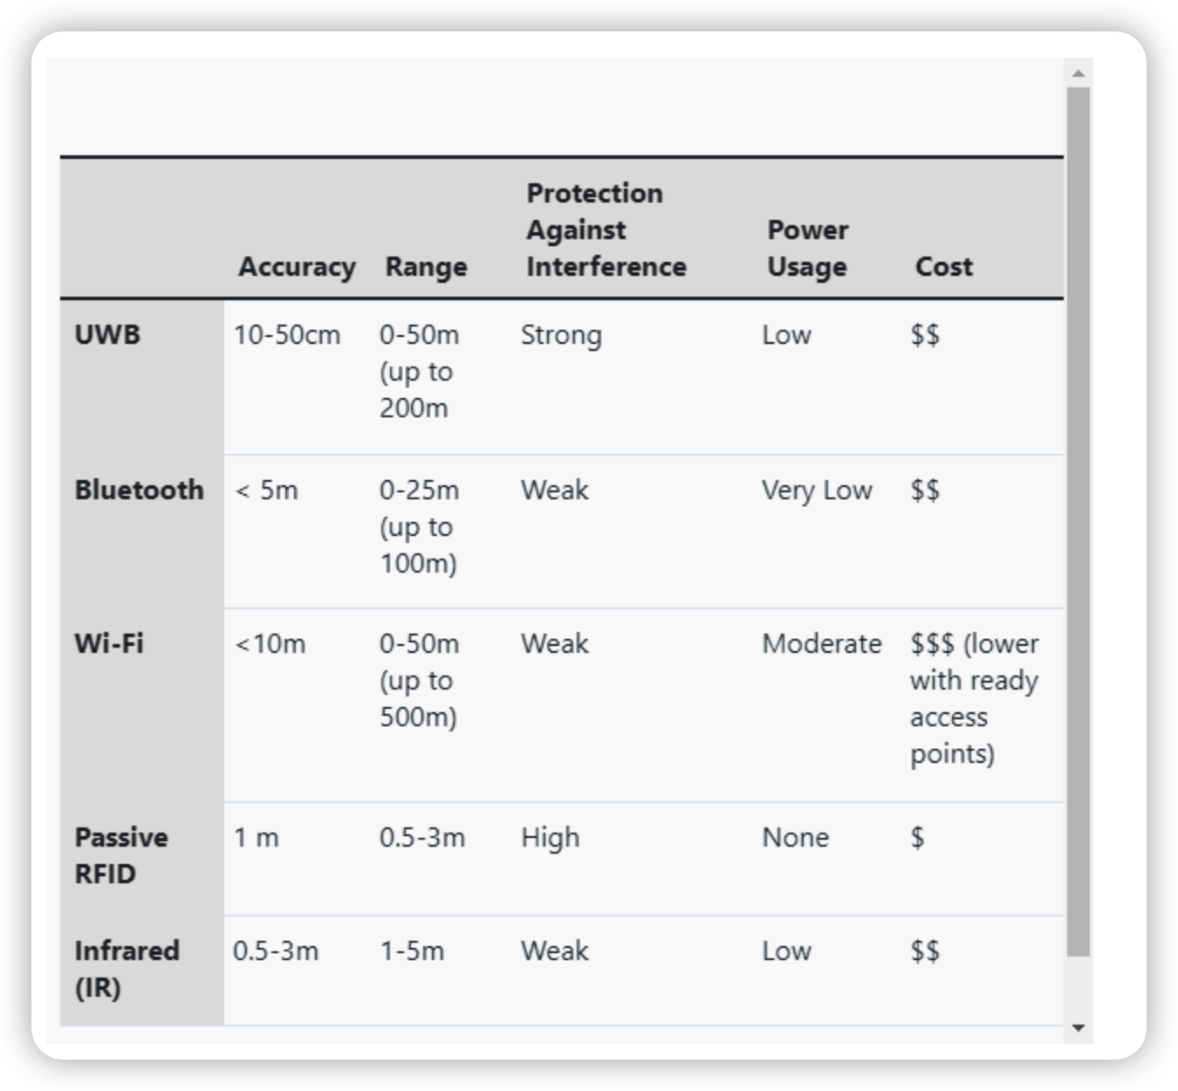Source: [*https://ubisense.com/rtls-technology-the-ultimate-guide/*](https://ubisense.com/rtls-technology-the-ultimate-guide/)

Indoors positioning systems (IPS) [[1](https://www.ncbi.nlm.nih.gov/pmc/articles/PMC7730894/#B1-sensors-20-06766)] locate objects in closed structures, such as office buildings, hospitals, stores, factories, and warehouses, where the GPS proves to be inaccurate [[2](https://www.ncbi.nlm.nih.gov/pmc/articles/PMC7730894/#B2-sensors-20-06766)].

* possible traceability levels:

We overview the potential technologies and the possible traceability levels in [Section 2](https://www.ncbi.nlm.nih.gov/pmc/articles/PMC7730894/#sec2-sensors-20-06766). The levels represent the identification unit from the transportation unit (highest level— trucks, ships) to item unit (lowest level–raw material).

* potential manufacturing tasks

